What is Defect Life Cycle?
Defect life cycle, also known as Bug Life cycle is the journey of a defect cycle, which a defect goes through during its lifetime. It varies from organization to organization and also from project to project as it is governed by the software testing process and also depends upon the tools used.

Defect Life Cycle - Workflow:
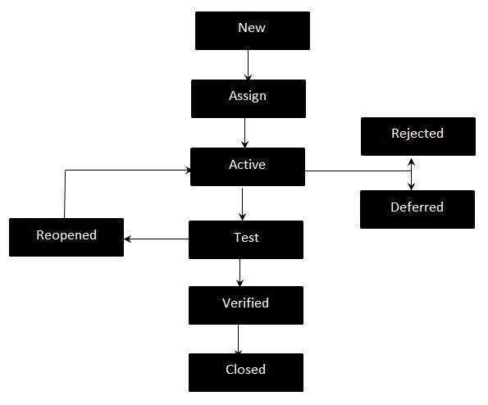

Defect Life Cycle States:
- New - Potential defect that is raised and yet to be validated.
- Assigned - Assigned against a development team to address it but not yet resolved.
- Active - The Defect is being addressed by the developer and investigation is under progress. At this stage there are two possible outcomes; viz - Deferred or Rejected.
- Test - The Defect is fixed and ready for testing.
- Verified - The Defect that is retested and the test has been verified by QA.
- Closed - The final state of the defect that can be closed after the QA retesting or can be closed if the defect is duplicate or considered as NOT a defect.
- Reopened - When the defect is NOT fixed, QA reopens/reactivates the defect.
- Deferred - When a defect cannot be addressed in that particular cycle it is deferred to future release.
- Rejected - A defect can be rejected for any of the 3 reasons; viz - duplicate defect, NOT a Defect, Non Reproducible.

